LCM OF TWO NUMBERS:

AIM:TO PERFORM LCM OF TWO NUMBERS USING 8086 PROCESSOR

PROGRAM:

LXI H, 8000H

MOV C, M

MVI B, 00H

INX H

MOV A, M

CMA

MOV E, A

;MVI D, FFH

MOV A,B

CMA

MOV D,A

INX D

LXI H, 0000H

JNC SKIP

MOV A,H

ORAL

JZ EXIT

JMP LOOP

SKIP: LHLD 8050

JMP NEXT

EXIT:LHL D 8050

HLT

: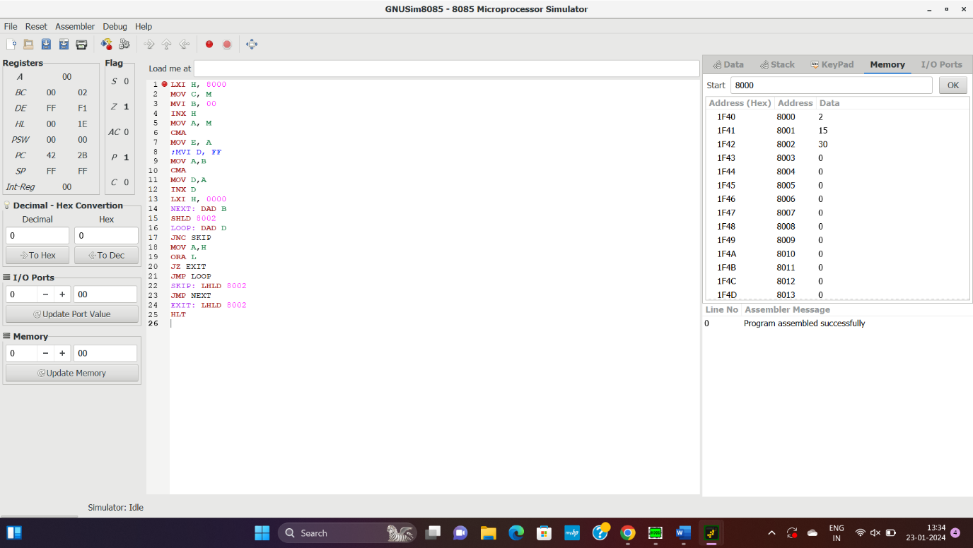

OUTPUT:

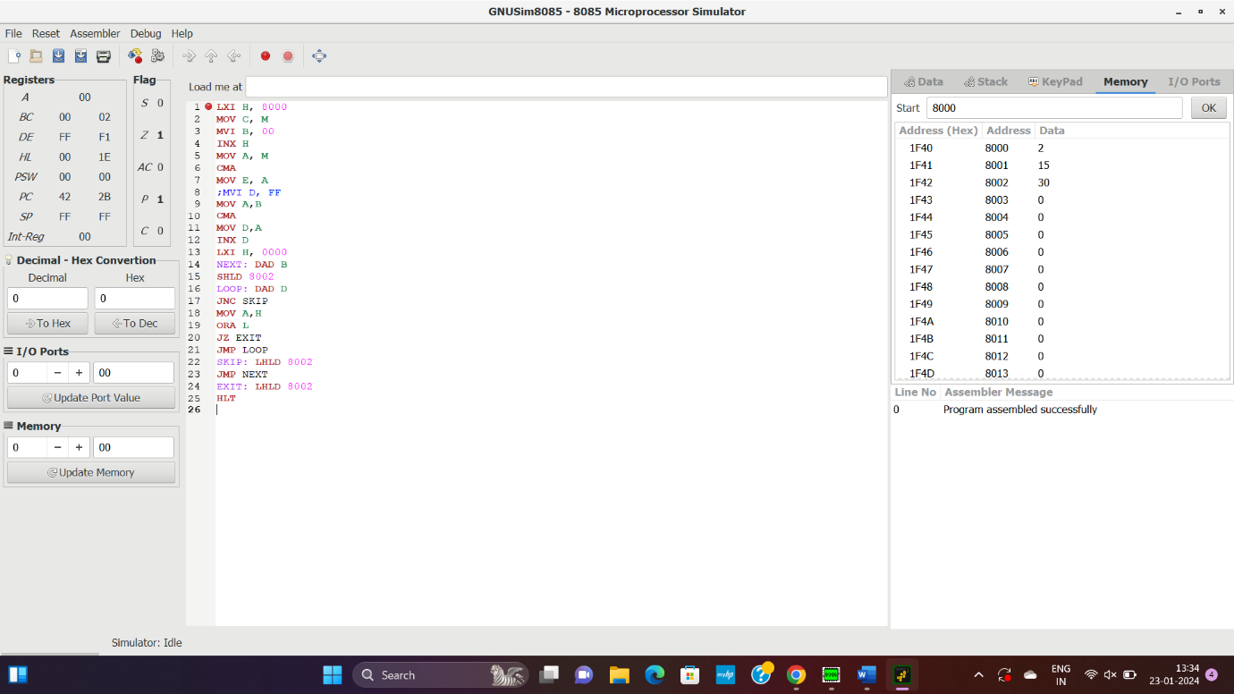

RESULT: THUS THE OROGRAM WAS EXCECUTED SUCESSFULLY USING 8085 PROCESSOR.